Date: 01.10.2021
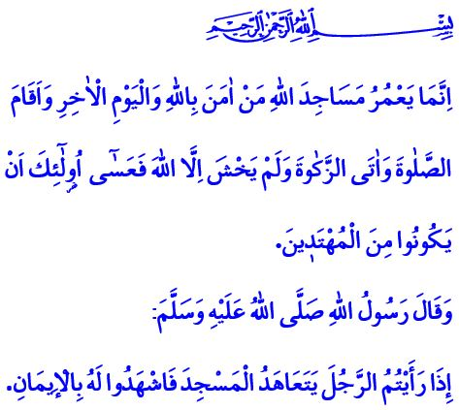
LOYALTY TO MOSQUES
Dear Muslims!
There was a woman in the ‘Asr al-Sa'adah who would devote her time to the upkeep and cleaning of the Masjid al-Nabawi. When the Messenger of Allah (saw) could not see the woman, he (saw) grew concerned and asked his Companions about her. The Companions told him that the woman had passed away. Then, our Prophet (saw) expressed his sadness by saying, “Why did you not inform me?” Thereafter, he (saw) went to the woman’s tomb, performed funeral prayer for her, and prayed to Allah (swt) for her.
This behavior of the Prophet (saw) is such a fine example of the loyalty expressed for those who are in the service of Allah’s (swt) masjids.
Dear Believers!
The Ka’bah in Mecca is the first place of worship and a source of abundance of divine blessings and guidance. Every masjid and mosque on the face of the earth is a branch of the Ka’bah.
Our mosques and masjids are the “Bayt Allah”, i.e. the house of Allah (swt). They are the symbol of Islam, the heart of tawhid, and the amplified sound of wahdat. They are the heart of our cities and lives. They are the wellspring of science, knowledge, and wisdom. Mosques and masjids, in the words of the Prophet (saw), are the most favorable places in the sight of Allah (swt).
Dear Muslims!
Our mosques and masjids are indicators of our devoutness to the Ka’bah, the Masjid al-Nabawi, and the Masjid al-Aqsa. We learn about the word of Allah (swt) in these places. In these places, we meet with the heirs of the Prophet (saw). We go through Divine and Prophetic education in these places. In these places, we are taught the rules and conventions of good manners. We embrace unity and solidarity, as well as brotherhood and loyalty, again in these places.
Dear Believers!
It is stated in the Holy Qur’an as follows, “The mosques of Allah are only to be maintained by those who believe in Allah and the Last Day and establish prayer and give zakah and do not fear except Allah...” Right, building a mosque is important. But what is even more important is to render our mosques prosperous with our presence. More important is to bring our hearts and minds together in the peaceful climate of our mosques. More important is to make our mosques lively by the presence of our women, men, children, youth, and elderly. More important is to strengthen our commitment to our Lord (swt) and to one another in our mosques, which serve as schools of wisdom.
Dear Muslims!
Every year, the 1-7 October is observed as “the Mosques and Religious Officials Week” in our country. Our Presidency’s theme for the Week this year is “Mosques, Religious Officials, and Loyalty”. Throughout the Week, we will have a deeper understanding of the place of mosques in our lives and hearts. We will remember with gratitude our men of loyalty, selfless religious officials, and servants of places of worship who have devoted their lives to serving for religion, and the deceased from among our great nation who have contributed to the construction and improvement of mosques.
I pray to our Lord Almighty (swt) that the Mosques and Religious Officials Week be auspicious. I would like to conclude this Friday’s khutbah with the following hadith of Prophet (saw) that demonstrates the importance of devoutness to mosques and congregations: “If you see a man who regularly comes to the masjid/mosque, then bear witness to his faith.”

Bukhari, Salat, 72.
Muslim, Masajid, 288.
Tawbah, 9/18.
Tirmidhi, Iman, 8; Ibn Majah, Masajid, 19. General Directorate of Religious Services

